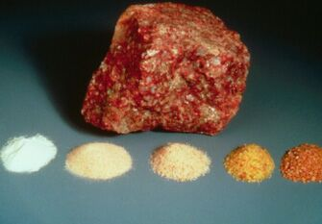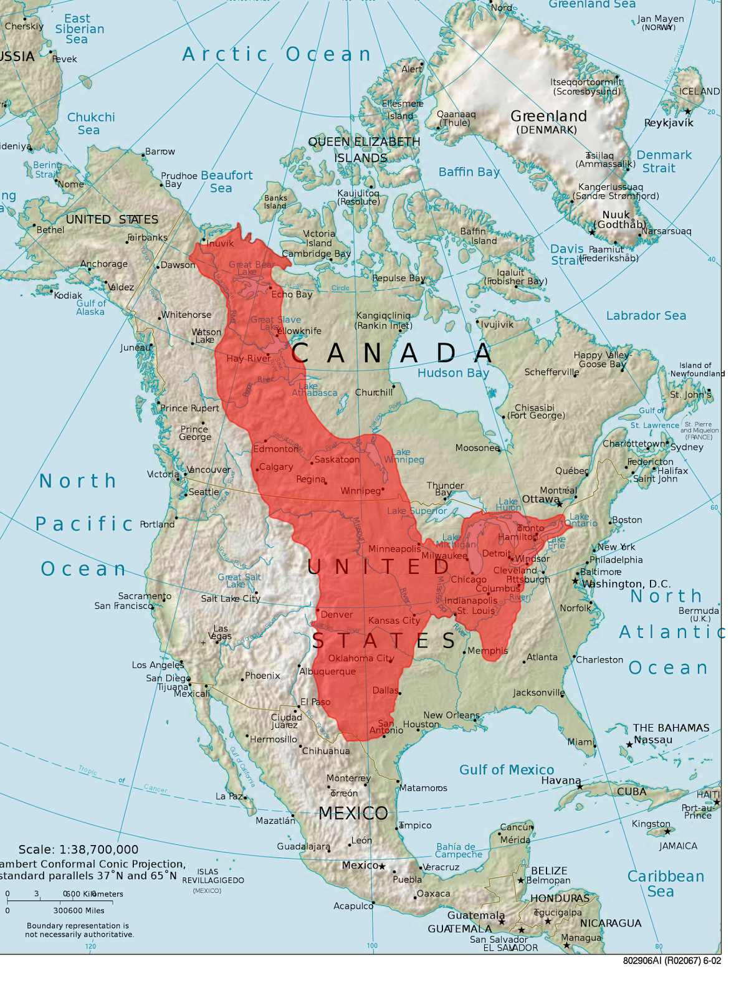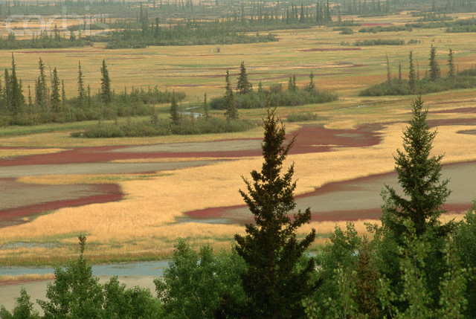

The Economy of the Interior Plains mostly consists of their natural resources. The Interior plains are rich in oils and minerals. They also have very rich soil, which makes farming there ideal. The main resources of the Interior plains are: Oil, natural gas, coal, Potash, Salts, Rich Soil, Forestry and Gypsum.

## Economy:

The Interior Plains are flat grasslands consisting of fertile soil and hot temperature in central North America and the US. The provinces encompassed by the Interior Plains are: Saskatchewan, Alberta, Northwest Territories and Yukon.

# What are the Interior Plains?

### Ms. Hall

### Grade 9

### Social Studies

🙞 🙜

By: Valerie

And Liam

The Interior Plains

Skill Testing Questions:

What area does the interior plains fill?

Sediment from what formed the Plains?

North summers can get up to ______ Celsius.

Types of trees: fir, pine and spruce.

Most of the land is flat and good for farming.

A lot of grass: Bluestem, Porcupine and June.

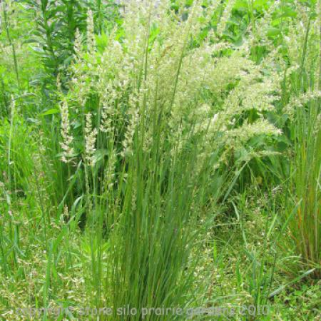

# Climate

## Vegetation

# Topography

The Interior Plains fill the area between the Canadian Shield and Western Cordillera. The topography of the Interior Plains is mostly flat grasslands with slight hills. The Southern side is mainly flat stretches of land with fertile lands while the Northern side is parkland that slowly develops into a taiga. Over the years erosion has cut into the soft rock in parts near Alberta/Saskatchewan.

# Early Settlers

North:

* Long cold winters / short summers
* Winter gets up to -30 degrees Celsius
* Summer gets up to 30 degrees Celsius
* The precipitation is lower than most of the other regions in Canada averaging 300 - 500mm.
* Driest region s/w 271 days without Precipitation
* Air from gulf of Mexico flows north -> violent weather (tornadoes/ march or June, blizzards and hailstorms)

South:

* Long, hot summers/ cold short summers
* Little Precipitation
* More bright sunshine each year than any other region in Canada.

The Interior Plains were formed when soils and sediment from rivers and lakes from the Canadian shield were deposited into the Interior plains. This process happened in layers and eventually the Interior Plains evolved into the flat, fertile land that it is today, with slight hills and river valleys. In the 1930’s major dust storms changed the Plains greatly, flattening the land even more and soon it became very hot, dry and dusty.

The Saulteaux, Cree, Blackfoot and Dene tribes first developed life in the Interior Plains settling near sources of food and water. They hunted caribou, moose or bison. Their hunters would travel along the grasslands following herds of bison. In the 1700’s Francophones started to explore the Plains and they set up fur trading posts with the first nations. A few of these trading posts grew into larger communities. The Cree and Metis people would trade food for fur with the traders as well as guide them throughout the land to allow them to travel further West and North.

# Formation